*Comprehensive Data Resource (CDR*) User Guide

Version 0.2

12/30/2015

EARLY DRAFT

**Version History**

This document combines information from a variety of existing sources in describing the design and context under which the Comprehensive Data Resource operates. This document is consistent with version 6.0 of the CDR.

|  |  |  |  |  |  |
| --- | --- | --- | --- | --- | --- |
| **Version Number** | **Implemented**  **By** | **Revision**  **Date** | **Approved**  **By** | **Approval**  **Date** | **Description of Change** |
| 0.1 | *William Brent Lander* | *12/30/2015* |  |  | *Working initial draft.* |
| 0.2 | Dave Tabor | 01/06/2016 |  |  | Review |
|  |  |  |  |  |  |
|  |  |  |  |  |  |
|  |  |  |  |  |  |
|  |  |  |  |  |  |
|  |  |  |  |  |  |
|  |  |  |  |  |  |

TABLE OF CONTENTS

1 Introduction 8

2 CDR Basics 8

2.1 CDR Capabilities 8

2.2 CDR Accounts, Roles and Responsibilities 9

2.3 Getting Started 9

2.4 Key Consideration 9

2.5 Logging Into and Out of CDR Data Services 10

2.5.1 Important Login Screen Links 10

3 Basic Data Entry 11

3.1 Process Overview 11

3.1.1 The Project Home Page 11

3.1.2 Search 12

3.2 Case List 15

3.3 Candidate List 15

3.4 Uploading Files 16

3.4.1 Process 16

3.5 Downloading a File 17

3.6 Submitting the Case for Review and Processing 17

3.6.1 Process 17

3.6.2 Failure to Provide All Required Information 17

3.7 Responding to Irregularities found in Review 18

3.7.1 Process 18

3.8 Viewing Deviations 19

3.8.1 Process 19

3.9 Adding a New Candidate 19

3.9.1 Process 20

3.10 Adding a Screening Enrollment Form to a Candidate 21

3.10.1 Process 21

3.11 Candidate Consent Form 24

3.11.1 Process 24

3.12 Entering Candidate Demographics Form 27

3.12.1 Process 27

3.13 Entering Candidate Health History Form 27

3.13.1 Process 27

3.14 Entering Candidate Social History Form 27

3.14.1 Process 27

3.15 Adding Candidate CaseRecords 27

3.15.1 Process 28

4 PRC Role 28

4.1 Process Overview 28

5 DM Role 28

5.1 Process Overview 28

6 LDS Role 29

6.1 Process Overview 29

7 Administrative Role 29

7.1 Preparinging a New Study 29

7.1.1 Process 29

7.2 Adding a New Study 29

7.2.1 Process 29

7.3 Associating a Study with a BSS 30

7.3.1 Process 31

7.4 Administering Users 32

7.4.1 Process 32

7.5 Administering Application Settings 36

7.5.1 Process 36

7.6 Modifying tissue list to include new types specimens 37

7.6.1 Process 37

7.7 Modifying the list of Organizations 38

7.7.1 Process 38

**Table of Figures**

Figure 1- The CDR in Context of the GTEx Study 9

Figure 2 - CDR Login 10

Figure 3 - Basic Data Entry Page Flow 11

Figure 4 - Search Home Screen 12

Figure 5 - Uploaded Files Line of Case Record Details Screen 16

Figure 6 - Screen for Upload PDF or ZIP File Selection 16

Figure 7 - Upload Files List Row on the Case Record Details Screen 17

Figure 9 - Example of an Attempt to Submit a Form with Missing Required Fields 18

Figure 10 - Query Tracker 18

Figure 11 - Deviation list 19

Figure 12 - Adding a Candidate from the Study Home Page 20

Figure 13 - Create New Candidate Record Form 20

Figure 14 - Example View Candidate Record Details 21

Figure 15 - Study Home Page With One Candidate in List 22

Figure 16 - Create Candidate Screening Enrollment Form 22

Figure 17 - Example Edit Candidate Screening Enrollment Form 23

Figure 18 - Updated View Candidate Record Details 23

Figure 19 - Study Home Page, Where Candidate Needs Consent Added 24

Figure 20 - View Candidate Record Details where Consent Verification Needed 25

Figure 21 - Create Candidate Consent Validation Form 26

Figure 22 - Expanded View Candidate Record Details Form 27

Figure 23 - Creating a Case Record for a Candidate 28

Figure 25 - Study List Screen with Two Example Studies 30

Figure 26 - Create Study Window 30

Figure 27 – Show An Individual Study Screen 31

Figure 28 - Edit Study Screen 31

Figure 29 - CDR Project Home Destination Page 32

Figure 36 - CDR Back Office 33

Figure 37 - Spring Security Management Console 33

Figure 32 - Create User, User Detail 34

Figure 33 - Create User - Roles 35

Figure 34 - Determining Which Users have a specifie Role 36

Figure 35 - CDR Applications Setting List 37

**Table of Tables**

Table 1 - Login Screen Important Information 10

Table 2 - Upper Right Corrner Screen Links 11

Table 3 - Definition of fields in Case List 15

Table 4 - Definition of FIelds in Candidate List 15

Table 5 - CDR Basic Applications Settings 36

# Introduction

The Comprehensive Data Resource (CDR) was developed to meet the challenges of real-world data collection of information about tissues gathered in the early stages of the Biospecimen Lifecycle[1] . This includes collection of information about potential candidates, their eligibility criteria and consent, medical history and surgical procedures used, acquisition, processing, handling, and storage. As the focus for biospecimen-based studies for cancer have turned to the molecular level, it is more important than ever that more comprehensive biospecimen annotation is collected during biospecimen collection, handling and processing.

# CDR Basics

## CDR Capabilities

The CDR is a web-based application, custom built to support specimen collection, clinical data entry and specimen logistics as well as curation and aggregation of study data. The capabilities reflect the needs of the supported projects, and include:

* Allowing remote users (e.g., researchers, and support staff) to securely enter, revise, and review data about biospecimen collection through a standard (HTTPS) web interface via a series of electronic forms with a sophisticated role-driven workflow.
* Connecting to remote systems via Web service APIs; such as LIMS, whole-slide imaging systems, and molecular analysis systems. There are APIs for authenticated (RESTful interfaces) to support real-time, two-way data transfers across a variety of data types.
* E-mail alerts automatically communicate timely information to project managers and data analysts, letting them know when to start working on something.
* Assisting Quality Assurance by auditing process flows through Data Management and Pathology teams
* Displaying control of PHI based on user entitlements and roles
* Reporting and analytics module for real-time data analysis, aggregation and report generation

In Figure 1, taken from GTEx source materials, the CDR acts as the data hub, storing information about the collections from the BSS, transferring and processing through the CBR, and handing off information on biospecimens to the Brain Bank and LDACC. Detailed description of the components can be found in **Error! Reference source not found.**. The flow of tissue is shown in red; the flow of information about those tissues is shown in blue. When tissues are collected by the BSSs, they use the forms hosted by the CDR in describing the case, biospecimens, and other clinical information. As the biospecimens transfer to the CBR, the CDR receives inventory information on those collected biospecimens (through web service messages) from the informatics system at the CBR. This instantiates workflows and creates triggers for data managers and pathologists to review cases. Once the tissues are processed, the CBR records subsequent transfer of materials to other specialized labs, including the LDACC for molecular studies. Results of various tests at these specialized labs also enter into the CDR via web services or user input, providing comprehensive study information. In the original document, the roles of “Honest Broker” included the capabilities of DM and PRC.

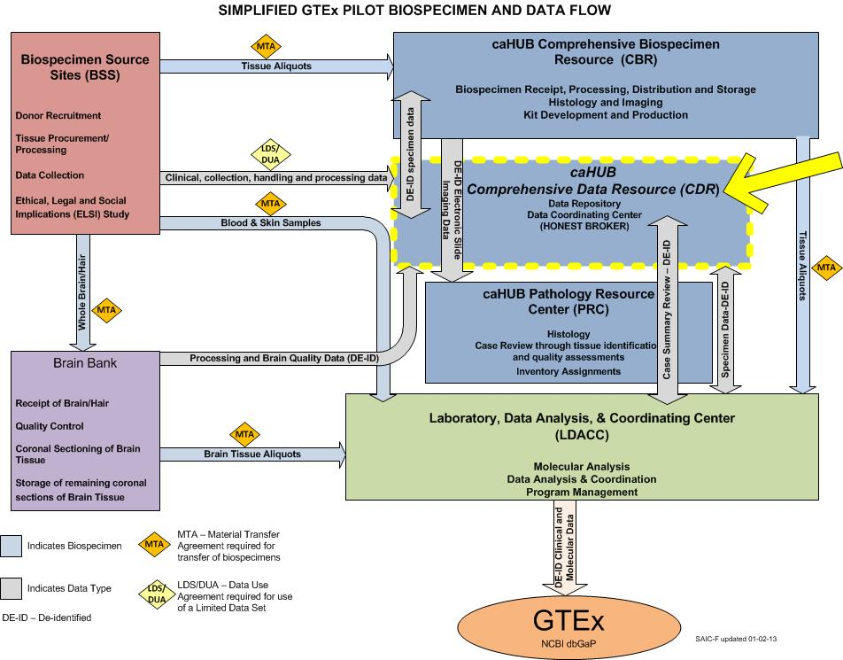

Figure 1- The CDR in Context of the GTEx Study

## CDR Accounts, Roles and Responsibilities

## Getting Started

## Key Consideration

If your CDR web session is inactive for 30 minutes, you will be automatically logged out. If you have completed but not saved the form on which you have entered data, that data will be lost.

## Logging Into and Out of CDR Data Services

When going to the CDR web site, the first page is always the login page.

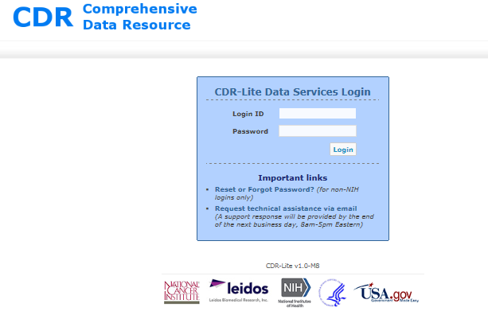

Figure 2 - CDR Login

**Note: On your initial login to the production site, the password must be changed.**

Both **Login ID** and **Password** are case sensitive. After a number of unsuccessful tries, your account will be locked. In this case, contact the CDR administrator and reqest help regarding the Password Change and Recovery process.

To logout, click on **Logout** at the upper right corner of any CDR screen. Upon logout, whether automatic or intentional, the CDR Login screen appears.

### Important Login Screen Links

At the bottom of the screen are various links for going to auxiliary sites such as recovery of passwords and an email link for requesting help.

Table 1 - Login Screen Important Information

| **Link/Information** | **Description** |
| --- | --- |
| **Forgot Password?** | The **Forgot Password?** link on the Home screen brings up a small window into which you can enter your user name. An email will be sent to your email address on record so you can complete the password change or recovery process. |
| **Request Help via Email** | This link opens your email client for sending a request for help to ncicahub_help@mail.nih.gov. |
| **Getting the CDR DS Version Number** | At the bottom of the Login screen (and every screen) is the CDR DS version number. When describing any problems, it is very important that you include this number. |

# Basic Data Entry

## Process Overview



Figure 3 - Basic Data Entry Page Flow

### The Project Home Page

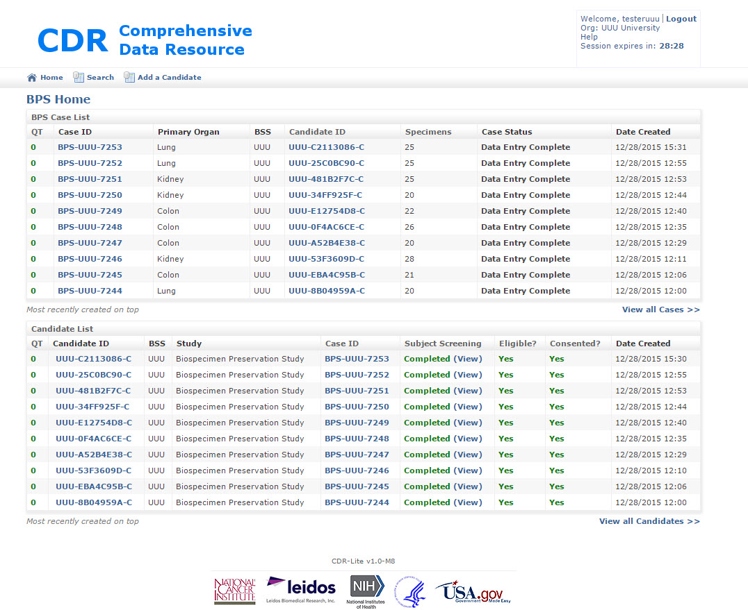

This is the first page you see after logging into CDR. You can also go to this screen at any time by clicking **Home**. The home screen displays a wealth of information for the most recent 10 candidates (this is configurable by the administrator), and you can use the View All Candidates or View All Cases links to browse the full list of candidates and cases (see discussion in subsequent section). From this single dashboard screen, you can determine the progress made through the system by a given candidate in the system: consent, eligibility and linked cases.

**Important Home Screen Links**

Several links are available at the top of the ProjectHome Page. Each link is discussed elsewhere in this guide. They are:

* Home
* Add New Candidate
* Search

**Upper Right Screen Links**

In the upper right corner of the home screen and all CDR DS screens a number of useful information items and links appear.

Table 2 - Upper Right Corrner Screen Links

| **Information Item** | **Description** |
| --- | --- |
| **Login Name and Organization** | Note that your individual Login ID and organization name appear there. As a BSS user, you only see cases and candidates from your organization. If the account is for a Biospecimen Source Site (BSS), only candidates and cases associated with that BSS are visible. |
| **Help (Email)** | The help link takes you to a page for creating an email to send to the CDR Admin. |
| **“Session expires” Time** | Because NCI mandates automatic logout for sessions with 30 minutes of inactivity, this feature is extremely useful, indicating the number of minutes and seconds until logout. To reset the time available, simply save any form or change from one CDR page to another. This text field turns red when less than 5 minutes are left before automatic logout. |
| **Search** | Search is discussed in detail in XXXXXXXXXXX |

### Search

The CDR has a powerful search capability. Clicking the **Search** link in the upper right corner of any screen brings up the Search Home screen,for setting up your search.

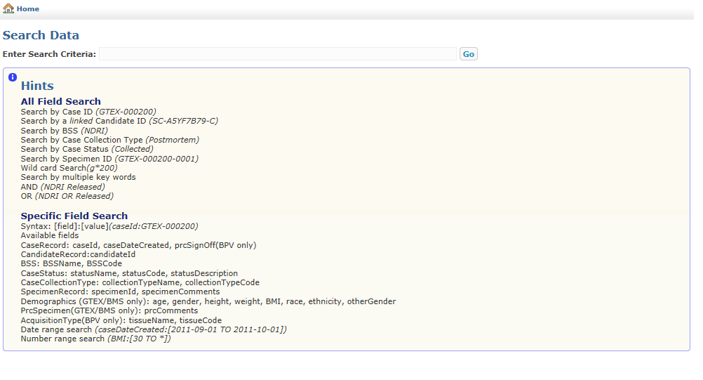

Figure 4 - Search Home Screen

You can search for any character string in any candidate or case information and of course any of the text strings appearing on the Home Screen and the View All views. For example, to find case BPV-000004, simply enter that text and click on **Go**.

Search operators that are supported by Simple Search, example queries, and their anticipated results are summarized in the table below.

| **Simple Search Operators** | **Example** | **Results** |
| --- | --- | --- |
| **Double quotes** (" ") will return specimens that contain the exact phrase quoted, in any of the fields. | **"Research Institute"** | Comments anywhere containing the exact phrase Research Institute  **Note:** Some fields may contain spaces, so searches should use double quotes. |
| An **asterisk (*)** is a *wild-card* search operator that can replace any number of characters in a search term.  It can be used in the beginning, middle or end of a search term.  It cannot be used in a quoted string. | **caseID:GTEX-100*5** | This will find a range of GTEx cases. |
| A **question mark (?)** is a *wild-card* search operator replacing a single character in the search term.  It can be used in the beginning, middle or end of a search term. Multiple question marks can also be used within a single search term, each will match one character. Question marks cannot be used in quoted strings. | **BSSname:ABC???** | Returns information related to a BSS whose name is six symbols long, and starts with “ABC”. |
| A **tilde (~)** is a search operator that will return terms that are spelled similarly to the term that prefaces it.  It should follow a single word search term. | **prcComments:preserved~** | Specimens containing the terms **preserved**, or **presreved** in the PRC Comments field. |
| Search operators can be used together and parentheses can be used to group queries. | **“2 pieces” AND (internal OR external)** | Specimens containing **2 pieces** and either **internal** or **external** |
| Prefacing a search phrase with **age:** will limit the query for the search phrase to the Age field. Generally, this matches multiple cases.  Other serch terms include:  caseID  candidateID  BSSName  BSSCode  statusName  statusCode  statusDescription  collectionTypeName  collectionTypeCode  gender  height  weight  BMI  Race  Ethnicity  otherGender  prcComments  tissueName  tissueCode | **age:45** | All specimens from cases with the age of *45.* |
| Prefacing a search phrase with **gender:** limits the query for the search phrase to the study's gender field. | **gender:Male** | All specimens having donor sex as Male. The only other acceptable value allowed is Female. To check for other gender selections, use **othergender:\*** |
| **Compound Searches**  **Any set of the above single searches can combined, making searches more focused, using the following notations.** **The examples all use single words, for clarity, but any of the above is acceptable.** | | |
| Including **AND** or **+** between search phrases will return images that contain both search phrases.  If more than one search term is entered, this search operator will be applied as the default.  If the operator is in a quoted string, it will be ignored. | **muscle AND skeletal**  or  **muscle + skeletal**  or  **muscle skeletal** | Comments anywhere containing both **muscle** and **skeletal** |
| Including **OR** between search phrases will return images that contain either, or both, search term. | **prcComments:(cortex OR medulla)** | PRC comments containing either **cortex,** or **medulla,** or both. |
| Including **NOT** or **-** (minus)between search terms will return images that do not contain the term that follows the operator.  This operator must be used with a search term that will return results.  If the operator is in a quoted string, it will be ignored. | **cortex NOT brain** | Comments anywhere containing **cortex** but not **brain**  **Note:** If you wanted to be certain that you were searching only for tissues (and, for example, not in the PRC comments), you could enter:  **prcComments:(cortex NOT brain)** |

## Case List

The **Case List** section of the Home Screen provides access to all cases that have not denied or withdrawn consent.

Table 3 - Definition of fields in Case List

| **Case List Field** | **Definition** |
| --- | --- |
| **Case ID** | The unique ID assigned to each case. |
| **Primary Organ** | The source of the tissue collected from the candidate. |
| **BSS** | Abbreviation for the BSS associated with the candidate. |
| **Candidate ID** | Specifies the Candidate ID to which this case has been linked. |
| **Specimen Count** | This column indicates the number of specimens collected for this case. |
| **Case Status** | This column indicates the current status of the case (see below Table 3-3 Case Status Name Descriptions). |
| **Date Created** | Indicates the date and time this case record was created. |

## Candidate List

The Candidate List section of the Home Screen provides access to all candidates in the system. Candidates that have been linked to a case are shown *in italics*.

Five fields make up the Candidate List; the Candidate List can be sorted in ascending or descending order by BSS, Study, or Date Created. The Candidate List fields are as follows:

Table 4 - Definition of FIelds in Candidate List

| **Candidate List Field** | **Definition** |
| --- | --- |
| **Candidate ID** | The unique identification number of each candidate. |
| **BSS** | Abbreviation for the BSS associated with the candidate. |
| **Study** | The study under which the tissue specimens were collected. |
| **Case ID** | Indicates whether the candidate is linked to one of the cases collected in the Bio4D system and, if linked, the case ID number. |
| **Subject Screening Form** | Indicates the status of data entry for this form: “Not Started,” “In Progress,” or “Completed.” |
| **Subject Consent Form** | Indicates the status of data entry for this form: “Not Started,” “In Progress,” or “Completed.” |
| **Eligible?** | This field is automatically populated according to whether or not the Subject Consent Form indicates that the patient has given consent or not. |
| **Consented?** | This field is automatically populated according to whether or not the Subject Consent Form indicates that the patient has given consent or not. |
| **Date Created** | Indicates the date and time this candidate record was created. |

## Uploading Files

**Note:It is very important that no personal identifiable information is included in uploaded files. This applies to the filename as well as the entire contents of each file.**

At any point that a case is marked “Data Entry Underway”, PDFs, Zip files or Word documents (.doc or .docx) of particular tissue collection and processing forms can be uploaded to the CDR DS.

### Process

To upload a file, click **Upload** on the Case Record Details Screen beneath the “Uploaded Files” row as shown below inFigure 5 - Uploaded Files Line of Case Record Details Screen.



Figure 5 - Uploaded Files Line of Case Record Details Screen

The Upload file screen appears as shown inFigure 6.



Figure 6 - Screen for Upload PDF or ZIP File Selection

Complete the following steps:

1. Select “Browse” to browse to the file (.pdf, .zip, .doc or .docx) you wish to upload.
2. Optional: Include comments about the upload.
3. Click **Upload**.

After upload is complete, the Uploaded Files row of the Case Record Details Screen will be updated (see Figure 3-5), showing your newly uploaded file. The Upload button is also still available for adding additional files related to the case.



Figure 7 - Upload Files List Row on the Case Record Details Screen

## Downloading a File

To download a file, locate the file you wish to download and click the corresponding **Download** link on the Uploaded Files row of the Case Record Details Screen as shown in.

## Submitting the Case for Review and Processing

When data entry has been completed for a case and before the PRC can begin its work on the case, the case status must be updatedtwice. The first update signifies that the entry to the required forms is complete. The second update signifies that any quality review at the BSS is complete, and the BSS is comfortable with the data quality. The need for an independent quality review depends on the experimental protocols in use for a study.

Additionally, if the DCC Data Management or PRC reviews indicate problems which require BSS remediation, then this process for submitting the case needs repeating.

### Process

1. Go to the Case Record Details screen, click the **(Change)** link next to **Case Status**. The Change Case Status screen appears.
2. Change the status to **Data Entry Complete**, indicating that all case data has been entered.
3. Change the status to **BSS QA Review Complete**, indicating that the BSS affirms that the case data is correct and consistent.
4. Click **Save** to change the status as appropriate.

After the status is **BSS QA Review Complete**, all update buttons disappear from screens, and signals data review and processing beginning on the case. No further entry can occur unless a later reviewer places the case into the status **Remediation**.

TheCase Record List screen and Home Screen reflect the change in status.

### Failure to Provide All Required Information

If you attempt to **submit** a form without filling out all required fields, the CDR DS will prompt you to enter the appropriate data and you will be unable to submit the form until all required data are entered.



Figure 8 - Example of an Attempt to Submit a Form with Missing Required Fields

After submission, all forms can still be edited by clicking **(View)** on the Case Record Details Screen and then clicking the **Resume Editing** button at the bottom of the form. Any edits must then be submitted again to overwrite the previously submitted form. When a new version is submitted, the “Date Submitted” Column on the Case Record Details Screen will be updated with the new date and time of submission.

## Responding to Irregularities found in Review

Once a case is submitted, it is reviewed by the Data Management team for consistency with appropriate procedures. If a question arises during review, the status of the case is changed to **Remediation**, and the BSS needs to respond to the question. The CDR implements this review feedback through the Query Tracker.

The Query Tracker, as shown in Figure 9, lists issues found during Data Management review of case data collected at the BSS. Specific issues found in a case are assigned to the source BSS during the case review, and the status changed to **Remediation**. This allows BSS to annotate resolution of the issue. Sites can access the list of queries by accessing the **Query Tracker** icon on the Home Screen or the **View Query list** on the Case Record Screen Details screen for the specified case.

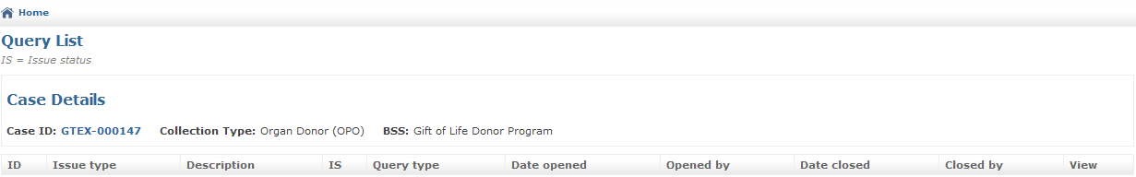

Figure 9 - Query Tracker

### Process

1. Go to the Query Tracker screen. The screen contains a list, by Case IDs, of the various issues, and associated details.
2. Click on the highlited Case ID to go to the specific Case Display screen. Find the problem and make the appropriate changes.
3. When all changes have been made for a particular Case ID, change the resubmit the case (see 3.6)
4. The case is no longer editable, but submitted for Data Management review.

## Viewing Deviations

Deviations are allowed variations from the exact procedure outlined in the related SOP. Deviations are recorded in the form of memos, stored in the CDR with the case. Retrieve the associated deviations by using the Deviation List screen.The Deviation list, as shown in **Error! Reference source not found.**, is a running list of deviations against the SOPs per case. [2]

### Process

1. Access the list of queries by accessing the Deviation list icon on the Home Screen or the **View Deviation list** on the Case Record Screen Details for the particular case.
2. Click on the View button at the end of each row for displaying the specific deviation memo.
3. Clicking on the highlited Case ID displays the Case Record Screen Details.

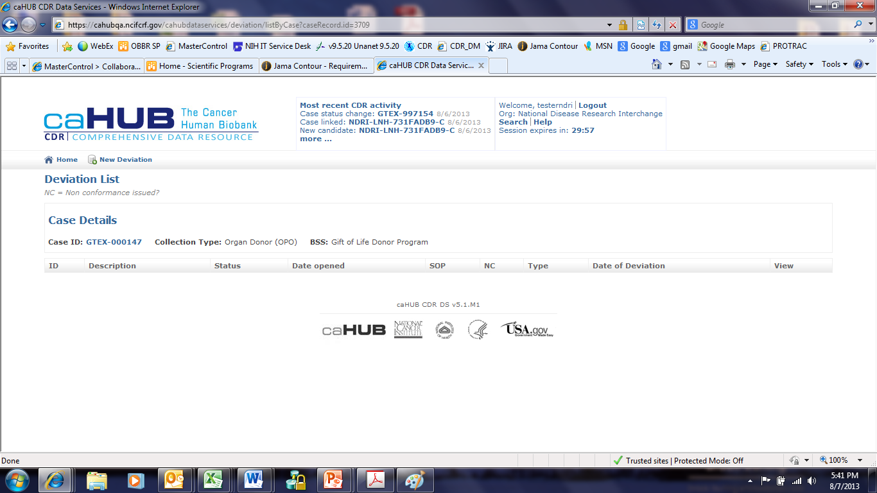

Figure 10 - Deviation list

## Adding a New Candidate

Candidate refers to a potential participant in an experiment. The Candidate becomes associated Case once they have been screened, …

### Process

1. After a candidate has been identified for entry into the CDR system, go to the Home Screen, then click **Add New Candidate** (Figure 11).

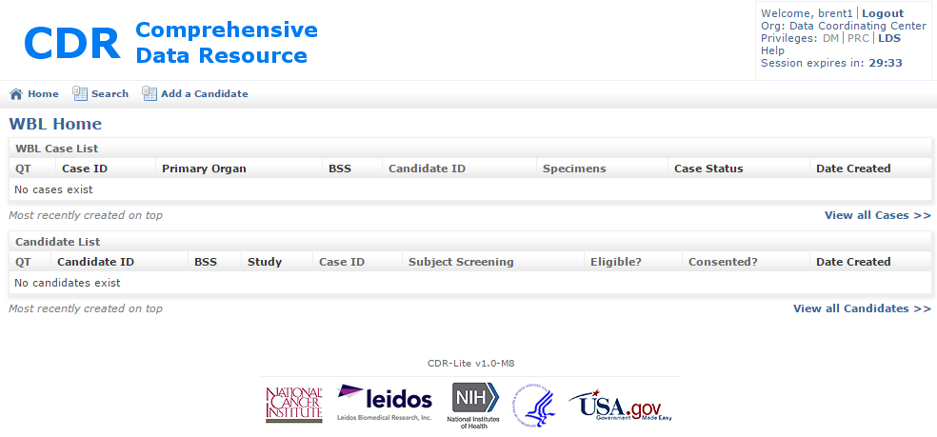

Figure 11 - Adding a Candidate from the Study Home Page

1. The **Create New Candidate Record** form appears as shown below inFigure 12.

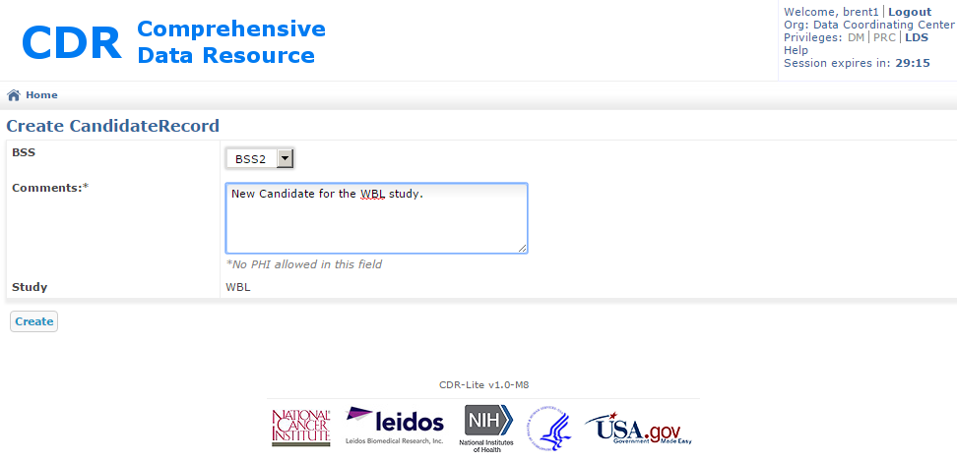

Figure 12 - Create New Candidate Record Form

1. Select the BSS the user represents.
2. The Study field is pre-populated with the name of the study.
3. When finished, click **Save**. The screen is updated to show the candidate record, as in Figure 13. The following points are important:
4. The candidate was assigned a unique identifier.
5. Both the Screening Enrollment, and Consent Verification fields were added, indicating those forms need successful completion before the Candidate can proceed in the study.

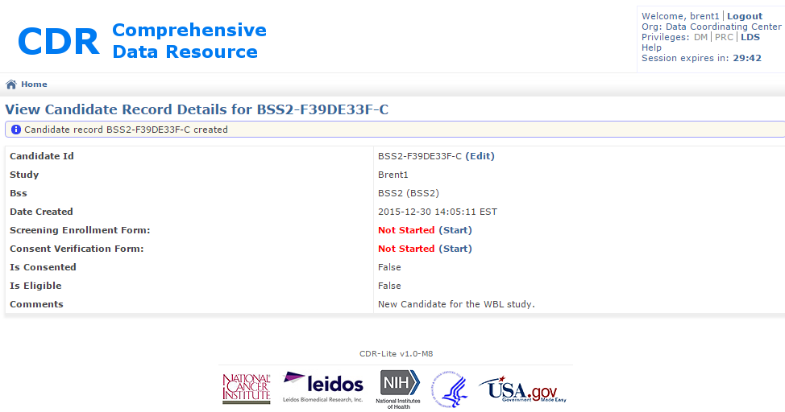

Figure 13 - Example View Candidate Record Details

1. To exit without creating a new Candidate, either use the back arrow on the browser, or click on the Home icon.

Note: a new candidate is not been consented, determined eligible, or linked to a case.

## Adding a Screening Enrollment Form to a Candidate

The screening enrollment form is where general information about the candidate gets entered.

### Process

1. After a candidate has been entered into the CDR system, go to the Home Screen, click on the Candidate ID(Figure 14).

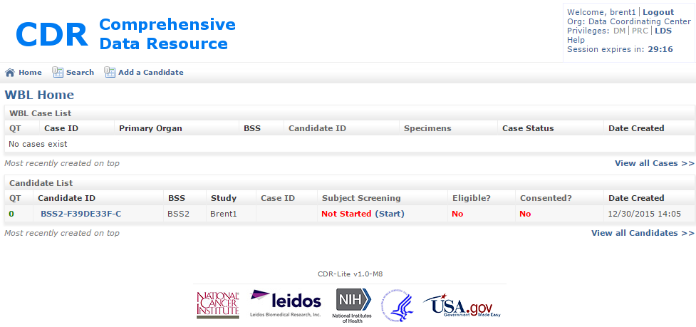

Figure 14 - Study Home Page With One Candidate in List

1. In the Candidate List there is a field titled “Subject Screening”, which has an entry Not Started (Start). Click on the Start. This progresses the screen to Candidate Screening.

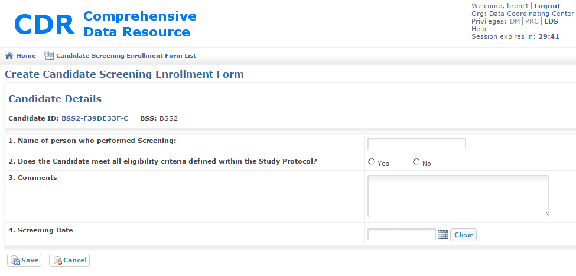

Figure 15 - Create Candidate Screening Enrollment Form

1. Fill out the form:
   1. Name of person who performed the Screening – text field for person
   2. Does the Candidate meet all eligibility criteria defined within the Study Protocol – Click on Yes or No, as appropriate.
   3. Comments – a place for the screener to record any insights they may have.
   4. Screening Date – Calendar select.
2. To save the information in the fields, click on the Save button. This will record the entries, and progress the screento the edit cazndidate screening enrollment form, for review of the entries (Figure 16.

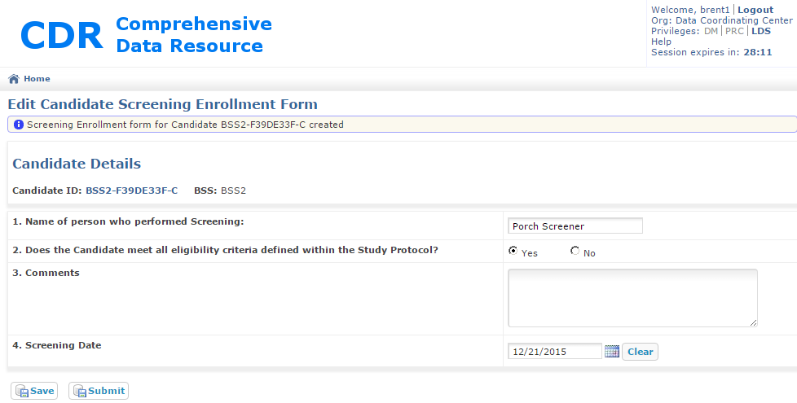

Figure 16 - Example Edit Candidate Screening Enrollment Form

1. If corrections are needed, change the appropriate fields, and click on save. Once all fields are correct, click on Submit. This progresses the screen to the screen, where the updated status is displayed (Figure 17).

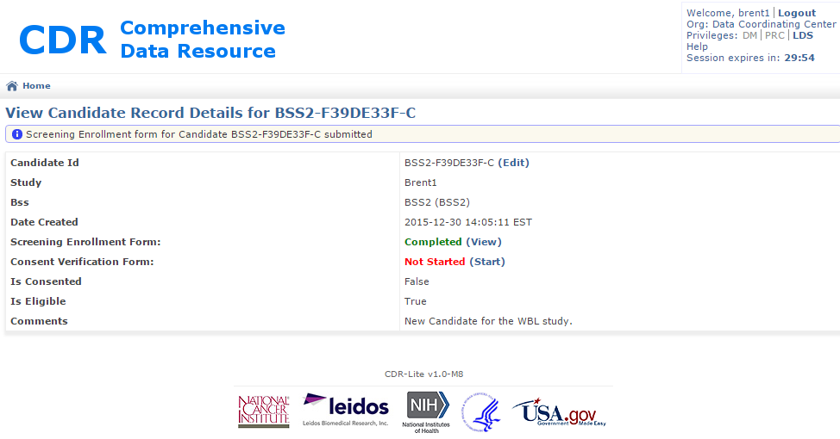

Figure 17 - Updated View Candidate Record Details

1. To Exit with out recording the entries, click Cancel, use the brouser’s back arrow, or click on the Home icon.

## Candidate Consent Form

After adding or editing a new candidate, beforyou must record consent information into the Candidate Consent Form. CDR Data Services tracks all candidates regardless of whether consent was obtained or not. Items 1 through 11 determine eligibility, while the remaining items contain important information that does not affect eligibility. Only the top portion must be completed before the form can be saved. Questions 13 and 15 require comments if answered “Yes.”

### Process

1. From the Study Home page, find the candidate to be consented.

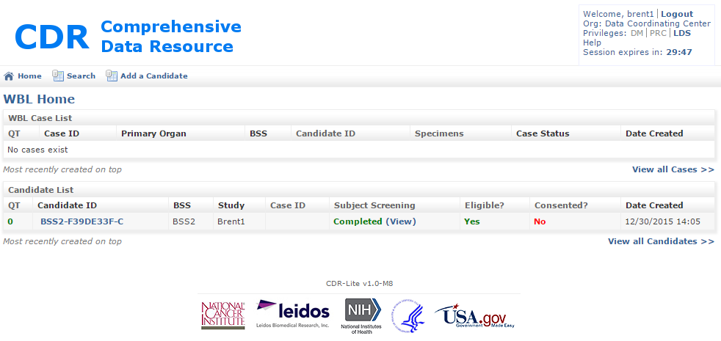

Figure 18 - Study Home Page, Where Candidate Needs Consent Added

1. Click on the Candidate ID. This progresses the display to the View Candidate Record Details form (Figure 18).

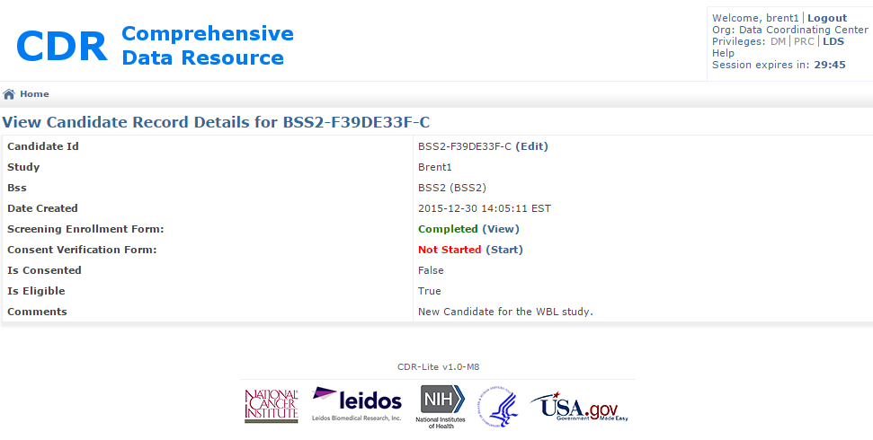

Figure 19 - View Candidate Record Details where Consent Verification Needed

1. In the row labeled Consent Verification Form, click on the highlited word Start. This progresses the screen to the Create Candidate Consent Validation Form (Figure 20) where the following field are entered.
2. Site Protocol Number – Unique identifier given to the protocol at this BSS for the procedure
3. Person Obtaining Concent – May be patient, Parent, or Guardian, depending on age
4. Relationship to donor – May be self, spouse, parent, sibling, other (specify)
5. Does the candidate meet all eligibility criteria within the study Protocol – Enter either Yes or No
6. Was Consent Obtained – Enter either Yes or No
7. Institutional version of Informed Consent Document – version of informed consent document that was agreed on. This may change during the course of a long study
8. IRB Approval Date – Date that the Informed Consent Document was approved
9. IRB Expiration Date – Date that the approval of the IRB is no longer valid.
10. Willingness to be contacted for Other Studies – Enter Yes or No if the candidate agrees
11. Specify Limitations if any – Free text, stating what limits on other studies the candidate would participate.
12. Comments – Free Text for the person obtaining consent may make notes. (optional)

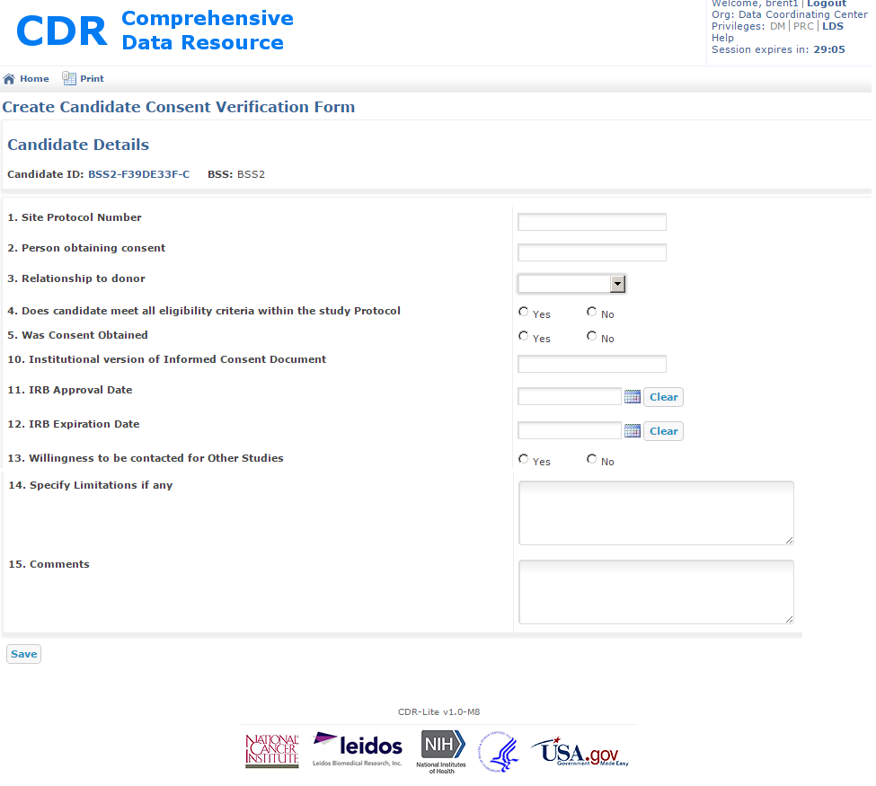

Figure 20 - Create Candidate Consent Validation Form

1. When complete, press the Save button.
2. The screen will then show an edit window for the Consent Validation Form. Here the values for the fields should be reviewed, and modified as necessary. (after modification, press Save again).
3. When complete, and accurate, press the Submit button, which goes to an expanded View Candidate Record Details screen, where additional information may be entered (Figure 21).

Figure 21 - Expanded View Candidate Record Details Form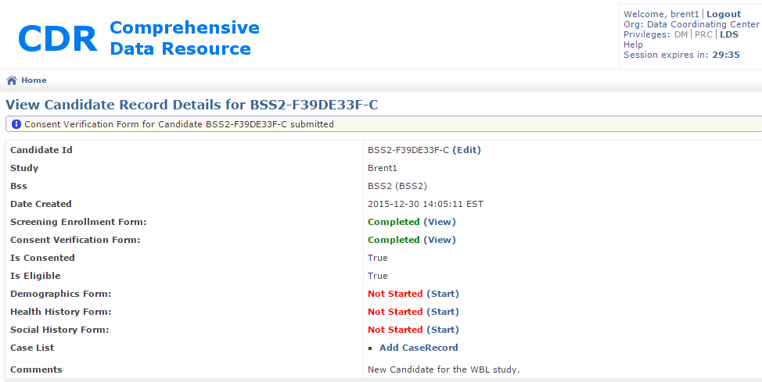

## Entering Candidate Demographics Form

### Process

## Entering Candidate Health History Form

### Process

## Entering Candidate Social History Form

### Process

1. Click **(Add)** under **Donor Eligibility** on the Home Screen.
2. After completing the form, click **Save**. The form reappears, enabling further edits.
3. Click **Home** to return to the Home Screen. Note that the candidate’s **Consent Verified** and **Donor** **Eligibility** columns are now updated.

## Adding Candidate CaseRecords

### Process



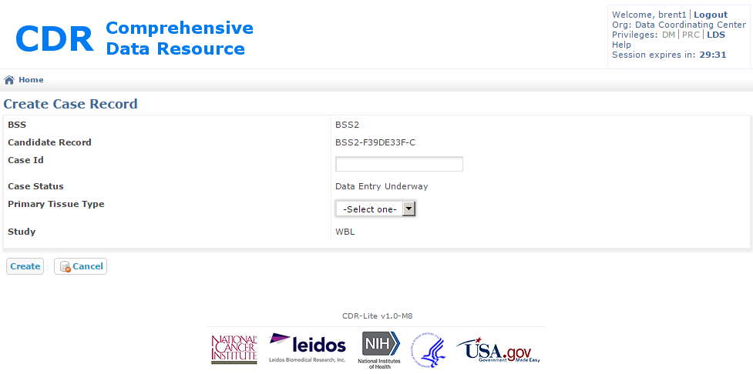

Figure 22 - Creating a Case Record for a Candidate



# PRC Role

## Process Overview

[Provide a concise description of the overall processes managed by the software, and how the PRC user interacts with the system. As applicable, reference related processes and corresponding documentation (you may want to create an ordered list of each workflow/process to be covered).]

# DM Role

## Process Overview

[Provide a concise description of the overall processes managed by the software, and how the data manager user interacts with the system. As applicable, reference related processes and corresponding documentation (you may want to create an ordered list of each workflow/process to be covered).]

# LDS Role

## Process Overview

[Provide a concise description of the overall processes managed by the software, and how the user with the LDS role interacts with the system. As applicable, reference related processes and corresponding documentation (you may want to create an ordered list of each workflow/process to be covered).]

# Administrative Role

[Provide a concise description of the context for this process or workflow, including any requirements or conditions that are relevant. Repeat this entire section for each major workflow or process.]

## Preparinging a New Study

This is the approved process for creating a new, configured, study.

### Process

Note: This process needs to be done in this order, as there are dependencies between the steps.

1. Login to CDR as an administrator
2. Modify the tissue list to cover those tissues in the study. (see section 7.6)
3. Modify the organization list to reflect the organizations participating in this study (see section 7.7)
4. Create the Study (see section 7.2)
5. Associate any Organizations that are BSSs with the Study. There must be at least one. (see section 7.3)
6. Create Users (see section 7.4)
7. Update the Application Settings as needed for this study (section 7.5)

## Adding a New Study

This is the approved process for creating a newstudy.

### Process

1. Login to CDR as an administrator
2. Add the DM role
3. Click on the DM Home icon
4. Click on the Vocabulary
5. Click on the Study controlled vocabulary item. This will bring up the Study List screen shown in Figure 23.

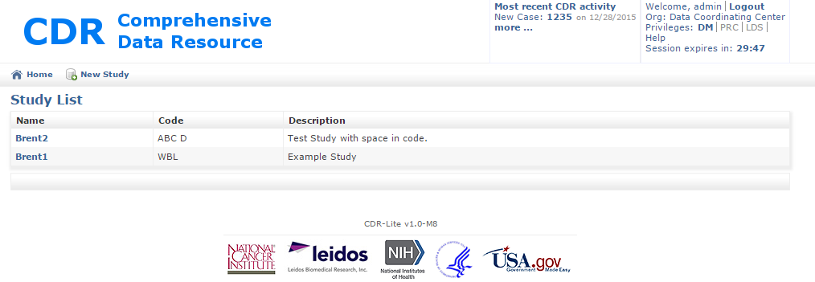

Figure 23 - Study List Screen with Two Example Studies

1. Click on the New Study icon. This will bring up the Create Study window shown in XXX.

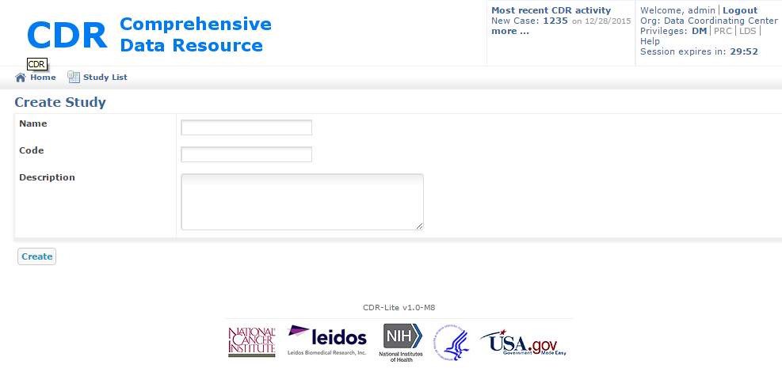

Figure 24 - Create Study Window

1. Fill out the fields as follows:

Name – Proper (long) name of Study. Study names should be unique.

Code – Prefix used in creating unique identifiers for items related to this study. This prefix should be unique across all studies maintained by this instance of CDR.

Description – Free text describing this study. Do not use any PII/PHI in this field.

1. Click on Create. This will bring up the Study List window, with the new study added.
2. To proceed without creating a study, use the back arrow on from the browser, or click on the Study List icon.

## Associating a Study with a BSS

After having added a study, and an Organization that is a BSS, a final step is associating the two.

### Process

1. Login to CDR as an administrator
2. Add the DM role.
3. Click on the DM Home
4. Click on the Vocabulary
5. Click on the Study controlled vocabulary item. This will bring up the screen shown in Figure 23.
6. Click on the name of the Study. This will show the screen shown in Figure 25

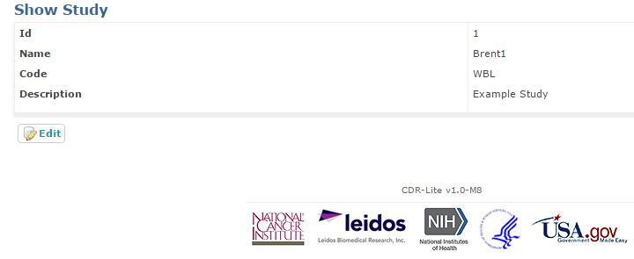

Figure 25 – Show An Individual Study Screen

1. Press the Edit button. This will show the screen in Figure 26.

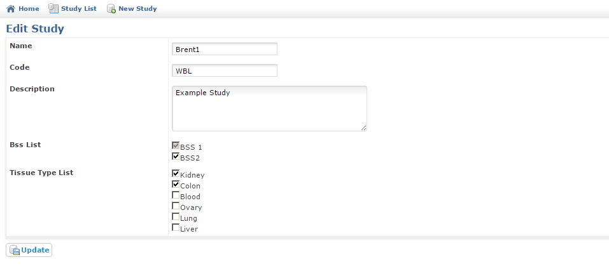

Figure 26 - Edit Study Screen

1. Update the Study fields as appropriate. The BSS List, and Tissue Type List reflect values added by the admistrator previously. Discussion of editing those lists is elsewhere in this document.
2. Click on the Update button. This will show the List Sites screen.
3. If you do not wish to commit the changes, use the back arrow on the browser, or click either on the Study List icon, or the Home icon.

## Administering Users

This process adds a user to the internal CDR user list. It does not impact other (e.g., LDAP) forms of authentication

Actions available here are:

* Look up a user’s current settings
* Add/create a user
* Modify an existing user

Note: Each study needs at least three (3) users, as follows

| User Role | Roles (All Roles Specified) |
| --- | --- |
| BSS user | ROLE_BSS |
| Data Manager | ROLE_DCC, ROLE_DM |
| PRC Evaluator | ROLE_DCC, ROLE_PRC |

Note: The usernames should be all upper case letters and numbers, with no spaces

### Process

1. Login to CDR as an administrator
2. Click on the “Back Office” button in the upper left .

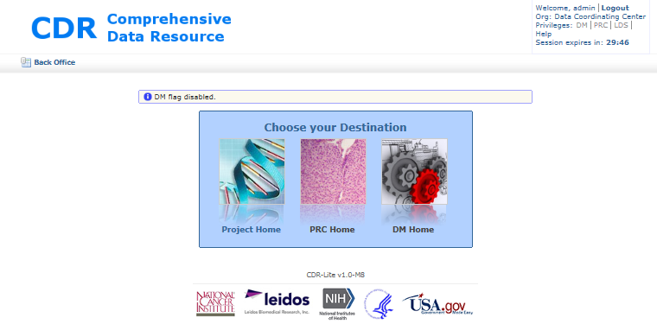

Figure 27 - CDR Project Home Destination Page

1. Once in the back office, click on the “User Administration” button

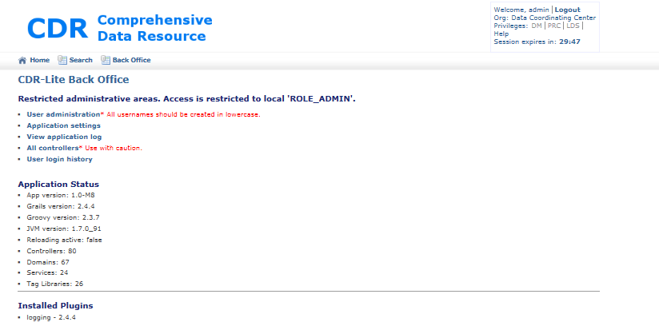

Figure 36 - CDR Back Office

1. This takes you to the Spring Security Module window

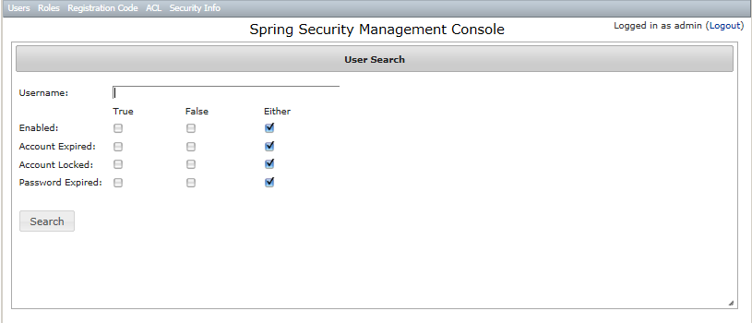

Figure 37 - Spring Security Management Console

1. To modify restrictions on an existing account
   1. Type in the username of the account to restrict/unrestrict.
   2. Press the Search button.
   3. Clicking on the check boxes causes the restrictions to change immediately.
      1. Enabled: True or Either, allows that username the option of logging in. False, they cannot login.
      2. Account Expired: True, blocks the account from further activity until enabled by an administrator. False or Either, the account is available for login.
      3. Account Locked: True, blocks the account for further activity, typically because of administrative reasons. False or Either, the account is available for login.
      4. Password Expired: Set either by the Administrator, or by a controller which requires passwords to be changed periodically. When True, the next time the account is used, progress blocks until the user enters a new password.
2. To create a new account
   1. In the Spring Security Management Console (Figure 37), click on the Users menu, and select the “Create” item. This will take you to the Create User window.
   2. Click on the “User Details” tab.

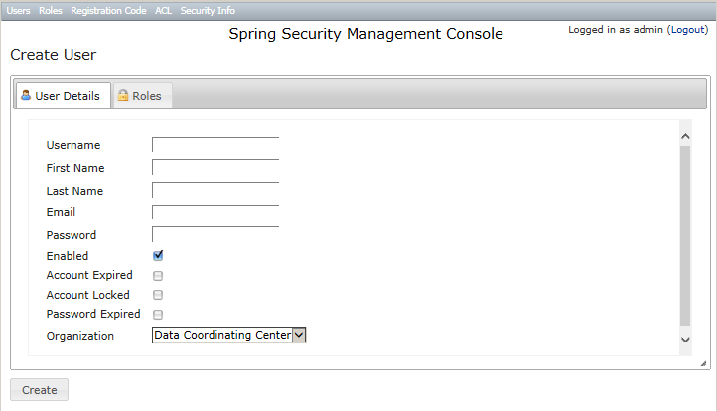

Figure 30 - Create User, User Detail

* 1. Fill out the form:
     1. Username – user names should be all lower case letters, and have no whitespace.
     2. First Name – The common name for the person associated with this account
     3. Last Name – The family name for the person associated with this account
     4. Email – Contact information for automatic alerts, warnings, and notifications
     5. Password – First password for the user logging in.
     6. Enabled – Checked by default. Uncheck if the account should not bea available when created (e.g., creating accounts proactively)
     7. Account Expired – if checked, the created account is blocked from use. Attempts to login get the account expired error message.
     8. Acount Locked – If checked, the created account blocks the user from making any changes.
     9. Password Expired – If checked, once the user logs in with the password from step v, then they will have to change the password immediately.
     10. Organization – By default, the organization is set to Data Coordinating Center.
  2. Now click on the “Roles” tab  
     Note- if you do not do this step, then no one can log in to this account!
     1. Click on the check boxes specifying the roles which this user can assume:
        1. ROLE_ADMIN – This account has administration privleges, including creating new users, modifying the vocabulary, and creating new studies.
        2. ROLE_BSS – This role is specified for a Biospecimen Source Site account , which is a place where biospecimens are collected.
        3. ROLE_DCC – This role is for Data Collection Center activities.
        4. ROLE_DM – This role is for Data Managers
        5. ROLE_LDS – This role allows the account user to see PHI data associated with a candidate/participant.
        6. ROLE_PRC – This role allows the account user to perform functions of the Pathology Research Center.
        7. ROLE_SERVICE –

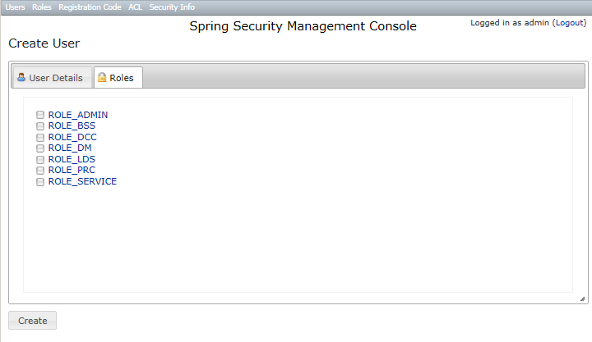

Figure 31 - Create User - Roles

1. After the information in BOTH tabs is complete, then click on the Create button in the lower left corner of the window.
2. To create determine which users are elegible to have a role
3. In the Spring Security Management Console (Figure 37), click on the Roles menu, and select the “Search” item. This will take you to
4. Click on the “Role Details” tab

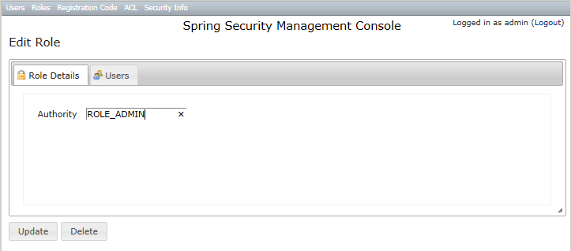

Figure 32 - Determining Which Users have a specifie Role

1. In the Authority tab, type the desired role.
2. Click on the “Update” button, and then select the “Users” tab.
3. The display is the accounts associated with that role.

## Administering Application Settings

This process configures the CDR with various installation-specific values. Some of these values will be set once, and not change. Others, such as the loginbulletin, may need frequent updating in keeping the users alerted to changes or interruptions.

### Process

1. Login to CDR as an administrator
2. Click on the “Back Office” button in the upper left .
3. Once in the back office, click on the “Applications Settings” text (Figure 36).
4. CDR now displays the AppSetting List page. As CDR is tailored to specific studies, additional settings may become available, specific to that study. The following table describes the meaning of each setting:

Table 5 - CDR Basic Applications Settings

| Name | Description |
| --- | --- |
| HELP_EMAIL | Email address for help desk queries. The address the browser sends email when users click on the “Help” button |
| Loginbulletin | Message displayed when a user logs in to the system |
| Deny user access for Disease study | Study specific setting |
| CDRLITE_ADMIN_DISTRO | When administrative events trigger inside CDR, an email goes to this address. |
| QUERY_RESPONSE_DCC_DM | St Exclude responses from local DCC DM users in this list from being counted in the AR query tracker report |
| NEW_QUERY_TRACKER_DISTRO | When a new query event triggesr inside CDR, an email goes to this address. |
| APERIO_IMAGE_DISTRO | When a new Aperio Image event triggesr inside CDR, an email goes to this address. |
| APERIO_URL | URL used in connecting to the Aperio image server |
| TUMOR_STAGE_KIDNEY | CSV list of applicable cancer stages. |
| TUMOR_STAGE_LUNG | CSV list of applicable cancer stages. |
| TUMOR_STAGE_COLON | CSV list of applicable cancer stages. |
| TUMOR_STAGE_OVARY | CSV list of applicable cancer stages. |
| TUMOR_STAGE_UTERUS | CSV list of applicable cancer stages. |

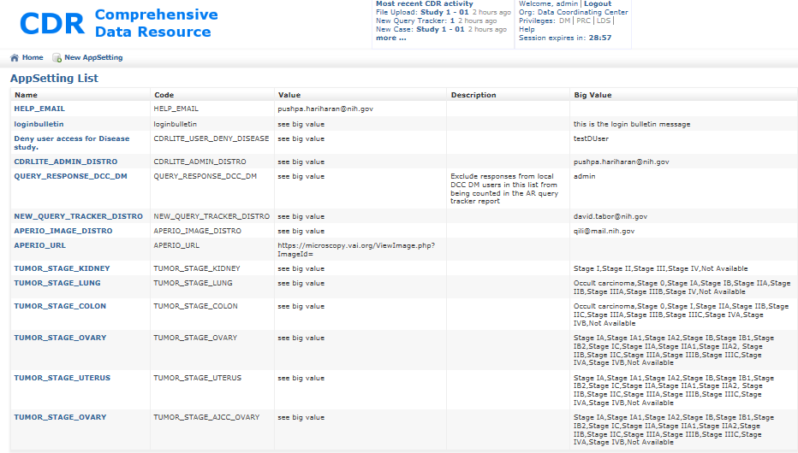

Figure 33 - CDR Applications Setting List

## Modifying tissue list to include new types specimens

This process configures the CDR to have references to the various types of tissues collected in a study.

### Process

1. Login to CDR as an administrator
2. Add the “DM” privledges, by clicking on DM in the Privleges in the upper right corner of the screen.
3. Click on the DM Home page. When there, click on the Vocabulary item.
4. On the vocabulary page, click on “Tissue Type.”
5. On the Tissue Type List page, look to see if all tissue types used in this study are available in under the “Name” column. If not, click on the “New Tissue Type” item at the top of the list. This changes the screen to the “Create Tisssue Type” page. The fields which need to be entered are:

* Name – (required) the common name of the tissue for collecting
* Code – (required) a unique set of letters (Upper case preferred) which is prefixed on the ID of each specimen of this tissue
* Description – (optional) text description of details of this tissue type. For example, could include requirements for gathering.

1. When complete, enter “Complete” filed.

## Modifying the list of Organizations

This process configures the CDR to have references to the various types of tissues collected in a study.

### Process

1. Login to CDR as an administrator
2. Add the “DM” privledges, by clicking on DM in the Privleges in the upper right corner of the screen.
3. Click on the DM Home page. When there, click on the Vocabulary item.
4. On the vocabulary page, click on “Organization.”
5. On the Organization List page, look to see if all organizations used in this study are available in under the “Name” column. If not, click on the “New Organization” item at the top of the list. This changes the screen to the “Create Tisssue Type” page. The fields which need to be entered are:

* Name – (required) the common name of the Organization
* Code – (required) a unique set of letters (Upper case preferred) which is prefixed on the ID of each specimen of this tissue
* Description – (optional) text description of details of this tissue type. For example, could include requirements for gathering.
* Shipping Address – (Required) descriptionof the shipping address for receiving tissues.
* Is Bss – (Required) Click on this box IF this organization is a biospecimen source site.

1. When complete, enter “Create” filed.
2. Use the browse back navigation page on the browser to leave this page.

NOTE: All studies in CDR need at least three (3) organizations:

* Data Coordinating Center – wher the information in the CDR is checked, and queries are started.
* PRC – where the collected specimen’s pathology is objectively quantified.
* BSS – where the biospecimen is originally collected and initial information gathered.

NOTE: Associating a BSS with a study requires an additional step. See the section on Associating a BSS with a Study.

**Key Terms**

The following table provides definitions and explanations for terms and acronyms relevant to the content presented within this document.

| **Term** | **Definition** |
| --- | --- |
| ABCC | Advanced Biomedical Computer Center |
| AOP | Aspect oriented programming is a programming paradigm that aims to increase modularity by allowing the separation of cross-cutting concerns. |
| BPV | Biospecimen Preanalytic Variables – a study sponsored by BBRB, which used CDR for managing study specific data. |
| BRIMS | Software system developed by Can Andel Institute for automating processes related to biospecimen logistical data and metadata. |
| BSS | Biospecimen Source Site – Institute from which human tissue is initially collected. |
| CDR | Comprehensive Data Resource |
| CDR-DS | CDR-Data Services (CDR core) |
| CDR-AR | Analytics and Reporting module for the CDR |
| CTC | Circulating Tumor Cells – a project scheduled to use the CDR capabilities. |
| dbGaP | A project of the NCBI, The database of Genotypes and Phenotypes (dbGaP) was developed to archive and distribute the results of studies that have investigated the interaction of genotype and phenotype. |
| DM | Data Management – the people and activities intent on preserving data integrity. |
| ELSI | Ethical, Legal and Social Issues – The Human Genome Project raised concerns in regards to how increased knowledge of the human genome could be used to discriminate against people. Part of the data in CDR refers to an ongoing study of these issues with participants. |
| FEA | Federal Enterprise Architecture |
| FNLRC | Frederick National Laboratory for Cancer Research |
| GORM | Grails Object Relational Mapping |
| Grails | A powerful computer software framework, based on the Groovy programming language, and emphasizing rapid software development of web based applications. |
| GTEx | NIH Common Fund's Genotype-Tissue Expression program |
| HHS | U.S. Department of Health and Human Services |
| LDACC | Laboratory, Data Analysis, and Coordinating Center, currently run by the Broad Institute |
| LDS | Limited Data Set – a reflection of the central data where PHI/PII data has been protected. |
| LIMS | Laboratory Information Management System |
| PII | Personally Identifiable Information - Individually identifiable health information |
| PHI | Protected Health Information - Health information, including demographic information; Relates to an individual’s physical or mental health or the provision of or payment for health care |
| RESTful | A type of Internet service interface typically between programs, which exchanges information. |
| SOP | Standard Operating Procedure – a detailed document describing precisely the performance of a protocol. |
| UI | User Interface – typically refers to the web-based graphical user interface which enables the various groups to enter/retrieve data from the CDR-DS or CDR-AR. |
| XML | Extensible Markup Language. A markup language that defines a set of rules for encoding documents in a format that is both human-readable and machine-readable. It is defined in the XML 1.0 Specification produced by the W3C, and several other related specifications, all free open standards. |

1. <http://biospecimens.cancer.gov/researchnetwork/lifecycle.asp>
2. The Deviation list is a separate and distinct list from the Query Tracker list, although some entries might have a relationship to an issue. For example, a site might have a collection where two samples exceed the SOP time for fixing. Each one of these first would be an issue in the Query list to verify the fixation time exceeding the time limit set in the SOP, and if verified, then an entry would be created in the Deviation list. Note that only one entry would be created in the deviation list, but there would be two issues in the Query list (on for each sample that exceeded the fix time). The deviation list would require workflow back and forth between the site and the caHUB team.